- Program ID : VC001MA1

- Display Layout
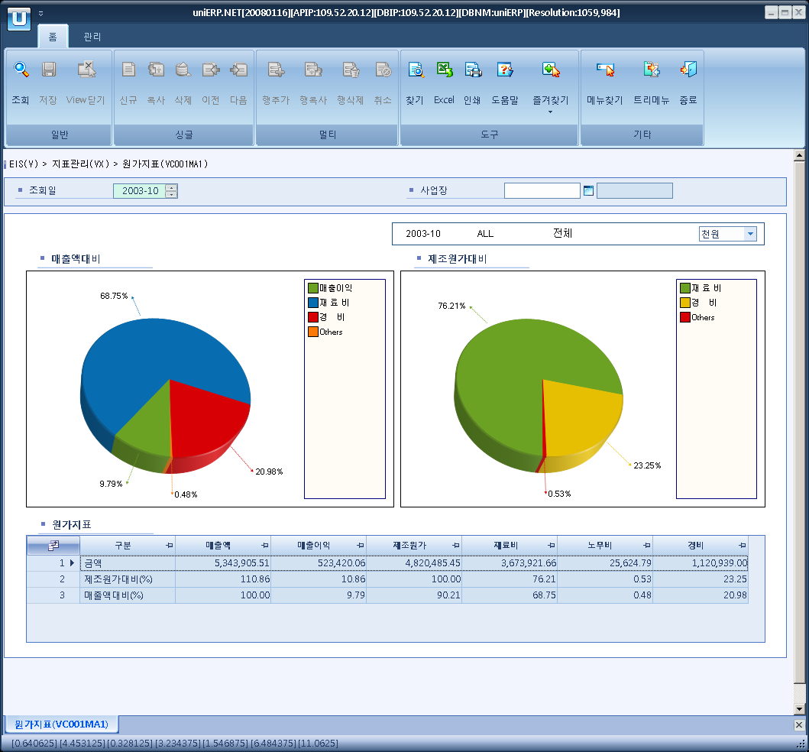

- Event flow
- Click Query button
- OnFncQuery -> DbQuery -> DataChange
- Display Unit combo change
- uniCombo1_ValueChanged -> DataChange

- SQL Statements
- Cost Index
SELECT ISNULL(VC0010T.TOT_AMT, 0), ISNULL(VC0010T.TOT_AMT, 0) - ISNULL(VC0010T.NOR_AMT, 0), ISNULL(VC0010T.NOR_AMT, 0)
FROM VC0010T
WHERE VC0010T.SP_ID = @strSpId
AND VC0010T.YYYYMM = @strYYYYMM
AND VC0010T.INDEX_CD = 'C02'

- Production Cost
SELECT ISNULL(VC0010T.NOR_AMT, 0), ISNULL(VC0010T.RATE, 0)
FROM VC0010T
WHERE VC0010T.SP_ID = @strSpId
AND VC0010T.YYYYMM = @strYYYYMM
AND VC0010T.INDEX_CD = 'C02'

- Material Cost
SELECT ISNULL(VC0010T.NOR_AMT, 0), ISNULL(VC0010T.RATE, 0)
FROM VC0010T
WHERE VC0010T.SP_ID = @strSpId
AND VC0010T.YYYYMM = @strYYYYMM
AND VC0010T.INDEX_CD = 'C03'

- Labor Cost
SELECT ISNULL(VC0010T.NOR_AMT, 0), ISNULL(VC0010T.RATE, 0)
FROM VC0010T
WHERE VC0010T.SP_ID = @strSpId
AND VC0010T.YYYYMM = @strYYYYMM
AND VC0010T.INDEX_CD = 'C04'

- Expense
SELECT ISNULL(VC0010T.NOR_AMT, 0), ISNULL(VC0010T.RATE, 0)
FROM VC0010T
WHERE VC0010T.SP_ID = @strSpId
AND VC0010T.YYYYMM = @strYYYYMM
AND VC0010T.INDEX_CD = 'C05'

